LAB221 Assignment | Type: | Short Assignment
 | Code: | J2.S.P0015
 | LOC: | 20
 | Slot(s): | 1

Title
Simple menu
Background Context
Menu is important in desktop java application, it provide needed function for an application that users can easily work. MenuItem also has icon and short-cut.
Program Specifications
Create an application using java swing to create a frame look like (1).
1. Main.java
Make a frame look like description below.

Function details:
- Display the GUI like figure (1).
- When users select a menu item, display the name of corresponding menu.

Expectation of User interface:

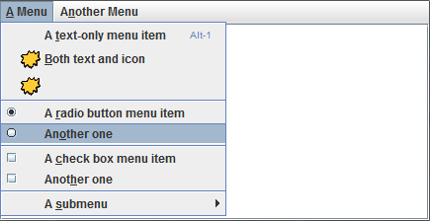 (1)
Guidelines

